Experiment 9

Name : Prem Vijay Hanchate
Roll no : 68 Class : TE/IT
Title: Data Distribution Analysis using Discrete and Continuous Distributions

Problem Definition:

To study and analyze different types of data distributions used in statistics and data science, and understand the characteristics of discrete and continuous probability distributions using graphical representation and interpretation.

Theory:
Data Distribution describes how data values are spread across a dataset. Understanding data distributions helps in analyzing patterns, variability, and behavior of data.
Different types of distributions are used in statistics and machine learning for probability analysis, prediction, and decision-making.
Distributions are mainly classified into:
- Discrete Distributions
- Continuous Distributions
Discrete distributions represent countable values, while continuous distributions represent measurable values over a range.
Commonly used distributions include:
  - Normal Distribution
  - Uniform Distribution
  - Binomial Distribution
  - Poisson Distribution
  - Exponential Distribution
  - Skewed Distribution
  - Bimodal Distribution
  - Log-Normal Distribution

Algorithm:

  - Start
  - Import required Python libraries.
  - Generate sample data for different distributions.
  - Plot graphs for continuous distributions.
  - Plot graphs for discrete distributions.
  - Analyze shape, spread, and behavior of distributions.
  - Compare discrete and continuous distributions.
  - Display results and graphs.
  - Stop.

Execution:

Step 1: Import Libraries
import numpy as np
import matplotlib.pyplot as plt import seaborn as sns
from scipy.stats import norm, poisson, binom, expon

Step 2: Normal Distribution
data = np.random.normal(0, 1, 1000) sns.histplot(data, kde=True) plt.title("Normal Distribution") plt.show()

Step 3: Uniform Distribution
data = np.random.uniform(0, 1, 1000) sns.histplot(data, kde=True) plt.title("Uniform Distribution") plt.show()

Step 4: Binomial Distribution
data = np.random.binomial(n=10, p=0.5, size=1000) sns.histplot(data)
plt.title("Binomial Distribution") plt.show()

Step 5: Poisson Distribution
data = np.random.poisson(lam=5, size=1000) sns.histplot(data)
plt.title("Poisson Distribution") plt.show()

Step 6: Exponential Distribution
data = np.random.exponential(scale=1, size=1000) sns.histplot(data, kde=True)
plt.title("Exponential Distribution") plt.show()

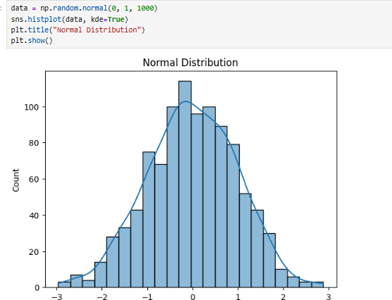

Fig 9.1: Normal Distribution Graph

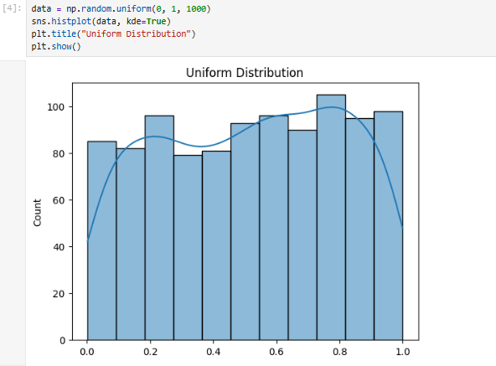
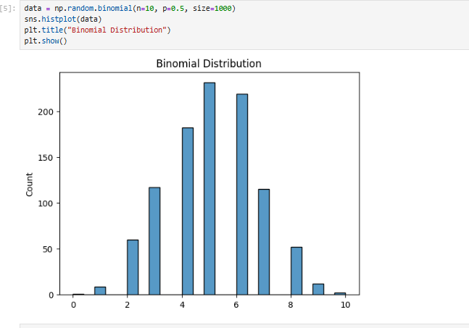
Fig 9.2: Uniform Distribution Graph

Fig 9.3: Binomial Distribution Graph

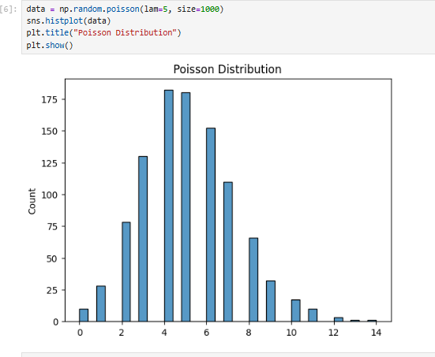

Fig 9.4: Poisson Distribution Graph
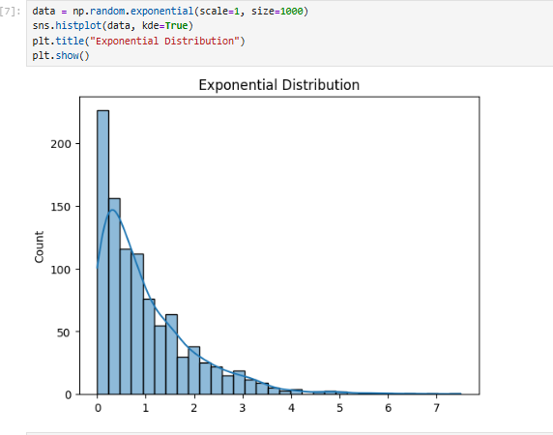

Fig 9.5: Exponential Distribution Graph

Interpretation of Results:
Figure 9.1 shows the Normal Distribution graph. The data is symmetrically distributed around the mean, forming a bell-shaped curve. Most values are concentrated near the center, while fewer values occur at the extreme ends.
Figure 9.2 shows the Uniform Distribution graph. The data values are distributed evenly across the entire range, indicating that each value has nearly equal probability of occurrence.
Figure 9.3 shows the Binomial Distribution graph. The graph represents the probability of obtaining a fixed number of successes in a specific number of trials. Most values are concentrated around the center.
Figure 9.4 shows the Poisson Distribution graph. The distribution represents count-based events occurring within a fixed interval. Most occurrences are concentrated around smaller values, while larger values occur less frequently.
Figure 9.5 shows the Exponential Distribution graph. The graph is right-skewed, where smaller values occur more frequently and the probability decreases rapidly for larger values. This distribution is commonly used to represent waiting time between events.

Result:
Different types of data distributions were studied successfully. Discrete and continuous distributions were analyzed and compared.
Graphical visualization helped in understanding the characteristics and behavior of distributions.

Conclusion:

In this experiment, various discrete and continuous probability distributions were studied and analyzed using graphical representation techniques. The experiment helped in understanding the characteristics, spread, shape, and behavior of different distributions. Data distribution analysis plays an important role in statistics, machine learning, and data science applications.

References:

- Scikit-learn Documentation
- Pandas Documentation
- Matplotlib Documentation
- Seaborn Documentation

